OpenMeetings tutorial for new users

Contents
1. Logging in / Creating an user account 2
1.1 Home view 4
1.2 Edit Profile 5
1.3 Upload avatar / image 6
2. Conference rooms (Meeting) 7
2.1 Entering a Conference room 8
2.2 Inside a conference room 9
3. Auditorium rooms 10
4. The Whiteboard 11
4.1 The toolbar 12
4.2 Upload a file to the whiteboard 14
4.3 Saving the whiteboard as an image / Files menu 15
5. Configuring microphone and webcam 16
6. Actions menu 17

1. Logging in / Creating an user account
This is a tutorial where I will be showing you how to use OpenMeetings as a normal user (for admins and moderators there is a completely different guide). I will start off by showing you what the login screen looks like.
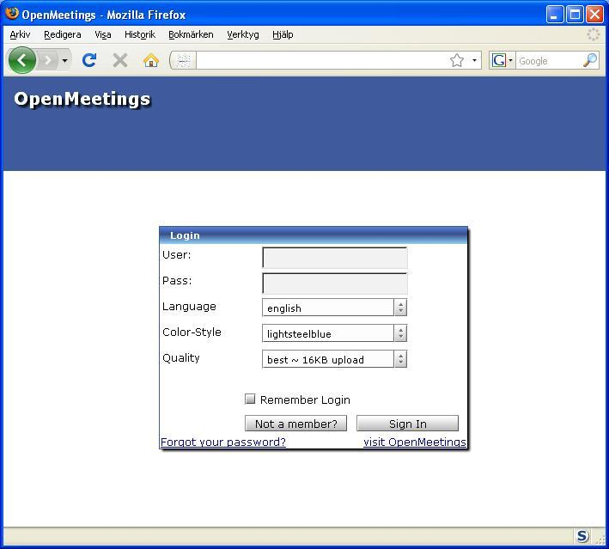
Picture 1 – Here you can see the login screen for OpenMeetings, you can change both language and color-style. If you aren’t a member you can sign up here (note: The sign up option might not be activated, the admin has the authority to enable or disable new members to sign up).
If you have a slower connection than DSL connection you might want to use medium quality, which can be chosen from the Quality menu.
In case the “Not a member” feature is enabled (if this feature is not enabled you will have to ask an admin to create an account for you) I will show you how to sign up for OpenMeetings, click on this will then give you a new window which looks like this:
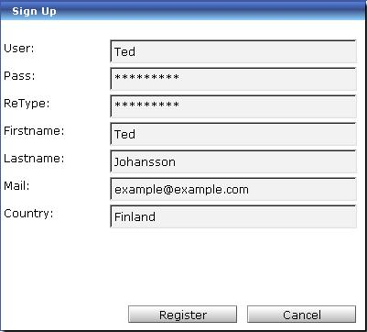
Picture 2 – This is the sign up window where you are to write the username, password you want. Your firstname, lastname, email and what country you come from.(Note: The sign up window will be empty.)
Once you have filled it in you click
If successful you should be able to login, so fill in your username and password (if it isn’t filled in already) and click .

1.1 Home view
After logging in you will enter the Homepage. You can also reach this page by clicking on the 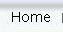 icon located in the upper left corner of the page.
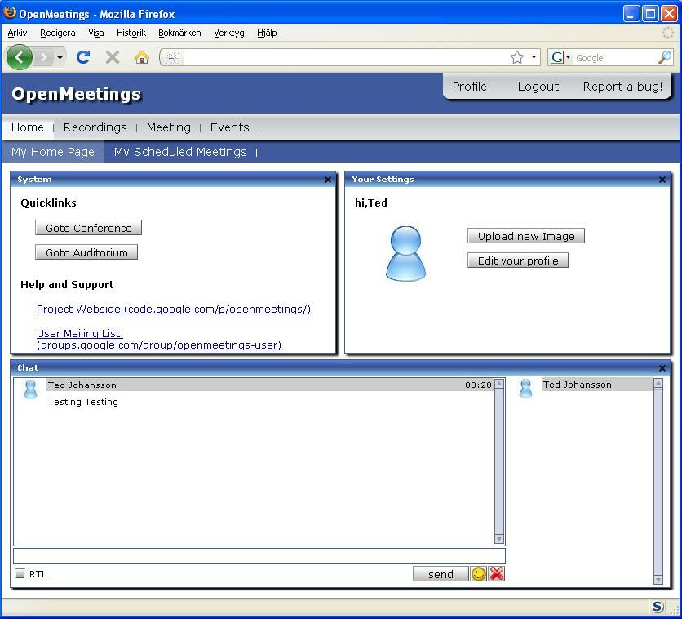
Picture 3 – Here you can see what the home page looks like. This is the default view, where you can navigate through the whole site.
The chat can be read by anyone able to log in, if you want to clear the chat history you press the button.
We have several different menus that all have their own sub-menus, I will go through them all one by one.
Under quick links you will find the and , I will explain the difference between a Conference room and an Auditorium room later on.

1.2 Edit Profile
Now I will show you what you can do in the edit profile menu, everything here is all straight forward.
First off start by clicking or (found on the main page) this will take you to the edit profile page.

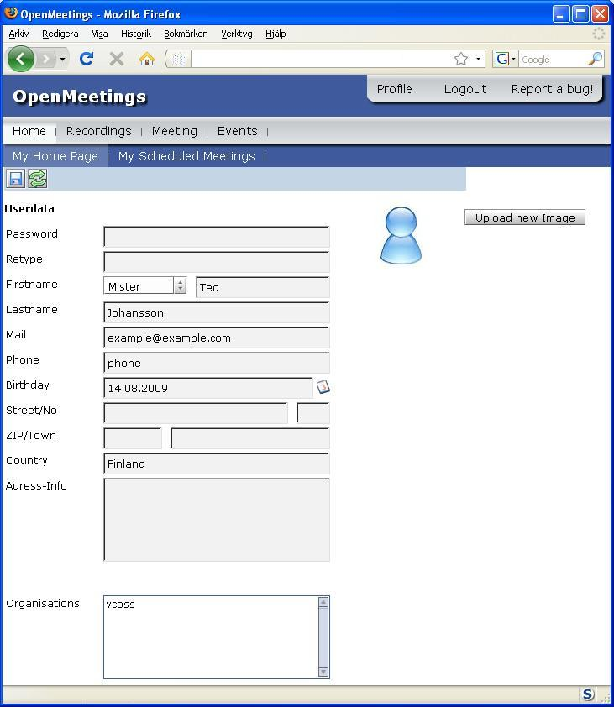
Picture 4 – This is the view of the edit profile page. Here both Country and Birthday must be filled in or you cannot save your information.
If you want to change the password you should just type the new password in the field next to Password, and then retype the exact same password in the box below the password box. Organizations can only be changed or added by an admin.
When you have typed all the information you find useful click the save button in the upper left corner.

1.3 Upload avatar / image

If you want to upload an image you can do it from here or from the Main page, by clicking on , which will prompt you a popup window that asks you to choose a file, here you:
- Press Select File
- Locate the picture on your hard drive that you want to use as your avatar
- Once you have located the picture you want to use click Open
- Then click Start Upload
Now it might take a while until the picture is uploaded, when it is done the picture will automatically be used as an avatar for you.

2. Conference rooms (Meeting)

Conference rooms are where you have your meetings. Here everyone can talk / chat, upload files to the whiteboard. To get to the Conference rooms you should click on (located on the main page) or the tab that can be found in the main menu. Both will take you to the same place (seen in picture 5 below).
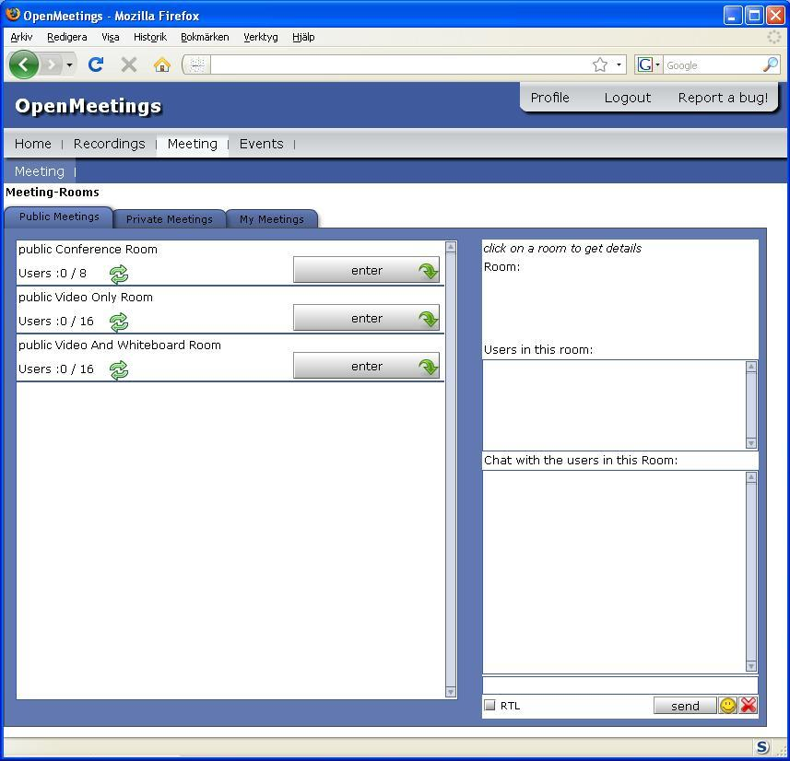
Picture 5 – Here you can see the different Conference rooms, public Conference Room with 0/8 maximum users, public Video Only Room and the public Video And Whiteboard Room with 0/16 maximum users.

2.1 Entering a Conference room
Start with entering a room by clicking next to one of the rooms, this will take you to that conference room.
Once you have entered the room you will be prompted with a question to choose published devices, your choices are:
- Audio and Video (For this you will need a webcam and a microphone)
- Audio only (For this you will need a microphone only)
- Video only (For this you will need only a webcam)
- No Audio/Video (static Image) (This requires neither webcam nor a microphone)
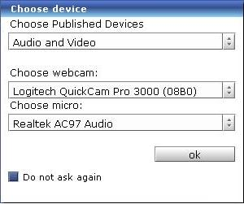
Picture 6 - When joining a room for the first time you will be prompted by this screen, asking you to choose published devices including what webcam you want to use, and what microphone. Clicking in the “Do not ask again” will save the information so it will automatically be used the next time you log in.
Once you have filled all those in and clicked ok, a new window will appear:
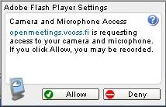
Picture 7 – this window asks if you want to allow OpenMeetings to use your web camera and microphone. Here you should click “Allow” if you click “Deny” you will not be heard nor seen in OpenMeetings.
Once you have done that you will be able to talk to / see the ones in the room

2.2 Inside a conference room

This is what a conference room looks like.
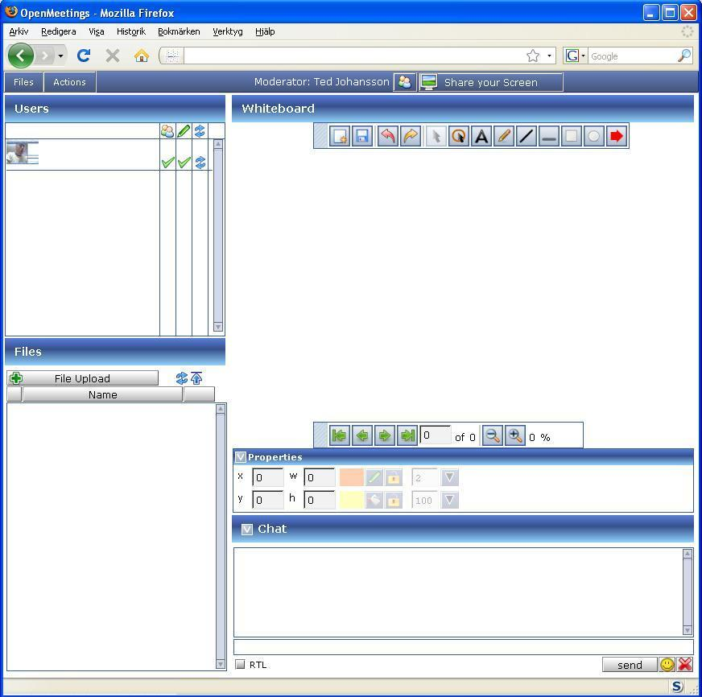
Picture 8 – This is the view of a conference room, with a whiteboard, chat, current users and all the files, that users of this room have uploaded to OpenMeetings.

3. Auditorium rooms

Auditorium rooms are different from Conference rooms; in the auditorium rooms only the moderator is able to talk or allow users to talk/ be viewed on webcam. Other than that the room is just the same as the Conference rooms. It has a Whiteboard for the moderator to share documents on.
Auditorium rooms can be reached from the main menu  or by clicking on the located on the main page.
The page itself will look similar to the Conference Room page, but it will only include Auditorium rooms. As seen in Picture 9 below.
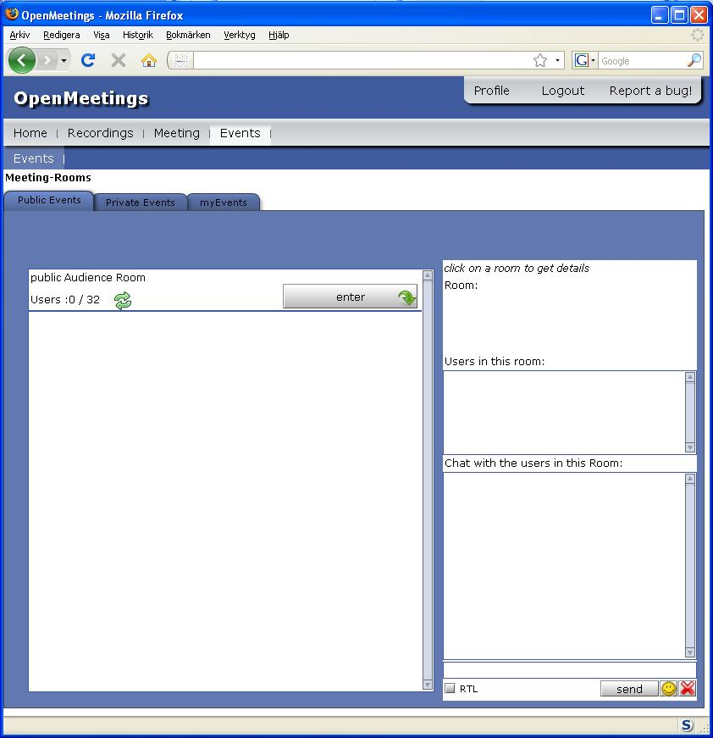
Picture 9 – This is what the Public Audience meeting room looks like, if the admin creates more rooms you will find more rooms in the meeting-rooms.
This is what an auditorium room looks like
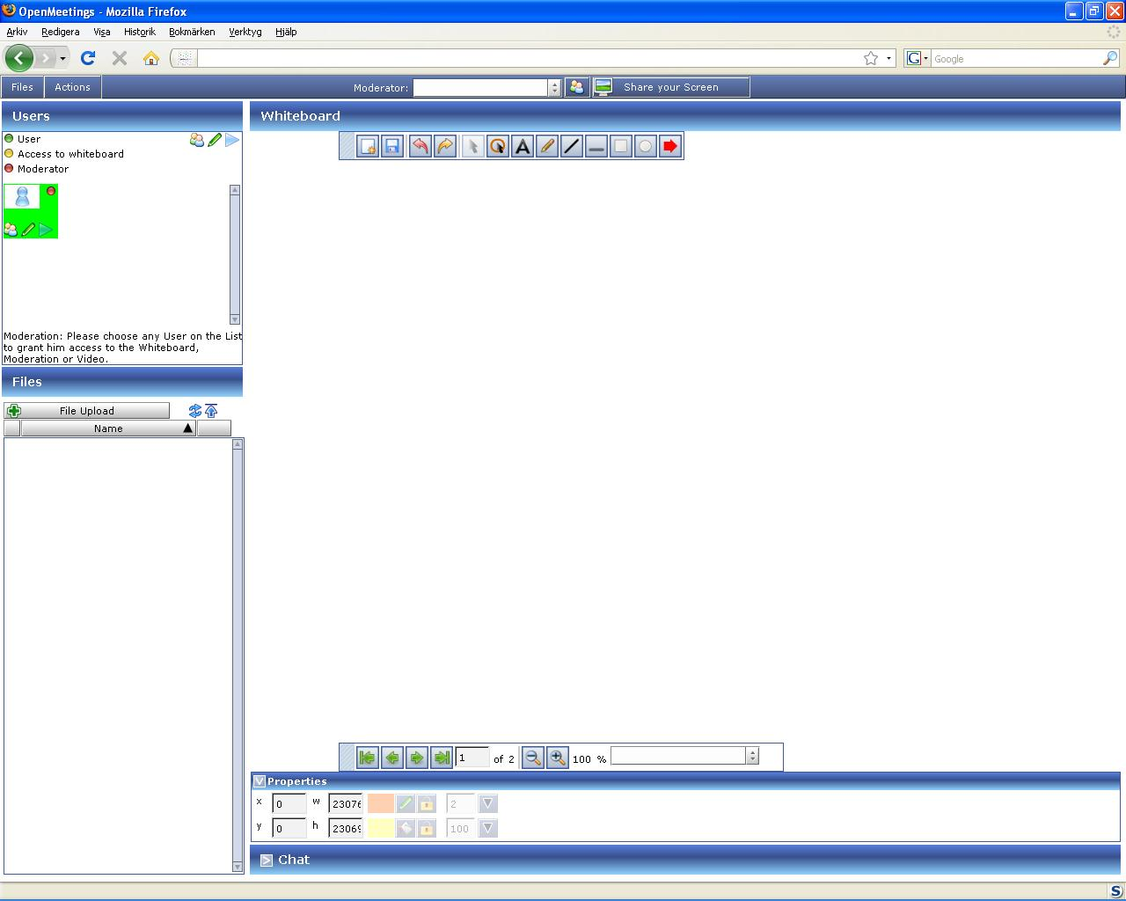
Picture 10 – This is the default view of an auditorium room.

4. The Whiteboard
The whiteboard is a very handy tool, it is capable of showing files that you upload, may it be .pdf files, jpg files or OpenOffice.org impress presentations, you can upload many other things as well, these are just examples.
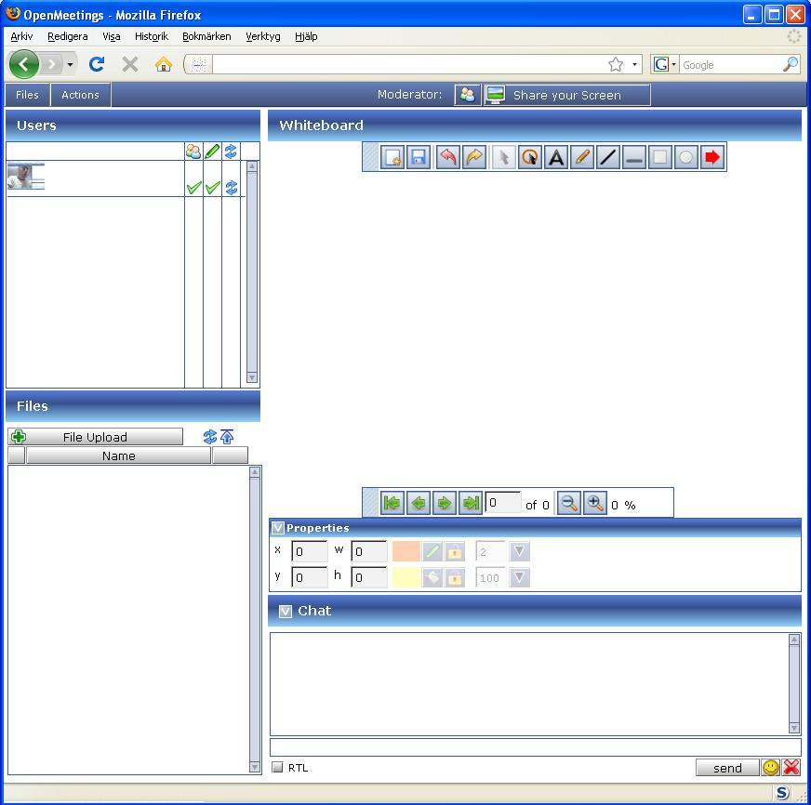
Picture 11 – Here is the view of a Conference room, the Whiteboard (located in the upper-right part of the screen).Once more and more members join in you will be able to see everyone using a webcam, and be able to hear what they are saying. The size of the webcam windows can be increased or decreased as well.

4.1 The toolbar

The toolbar located in the upper middle area is used to draw or point out things that are on the whiteboard.

Clear draw area Save and export Undo
Redo Select an object Pointer
Insert a text Paint Draw a line
Draw underline Rectangle Ellipse
Arrow

The properties tab is when you select an object, you can move it to a certain X, Y coordinate, define its width and height.
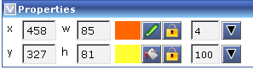
change linecolor. disable / enable linecolor or fillcolor.
change fillcolor the upper one means change line width and the lower one changes transparency.

You can also save the current whiteboard to a pdf file, and download the saved file, sort of like a printscreen but directly to .pdf, .jpg, .svg or .tif format

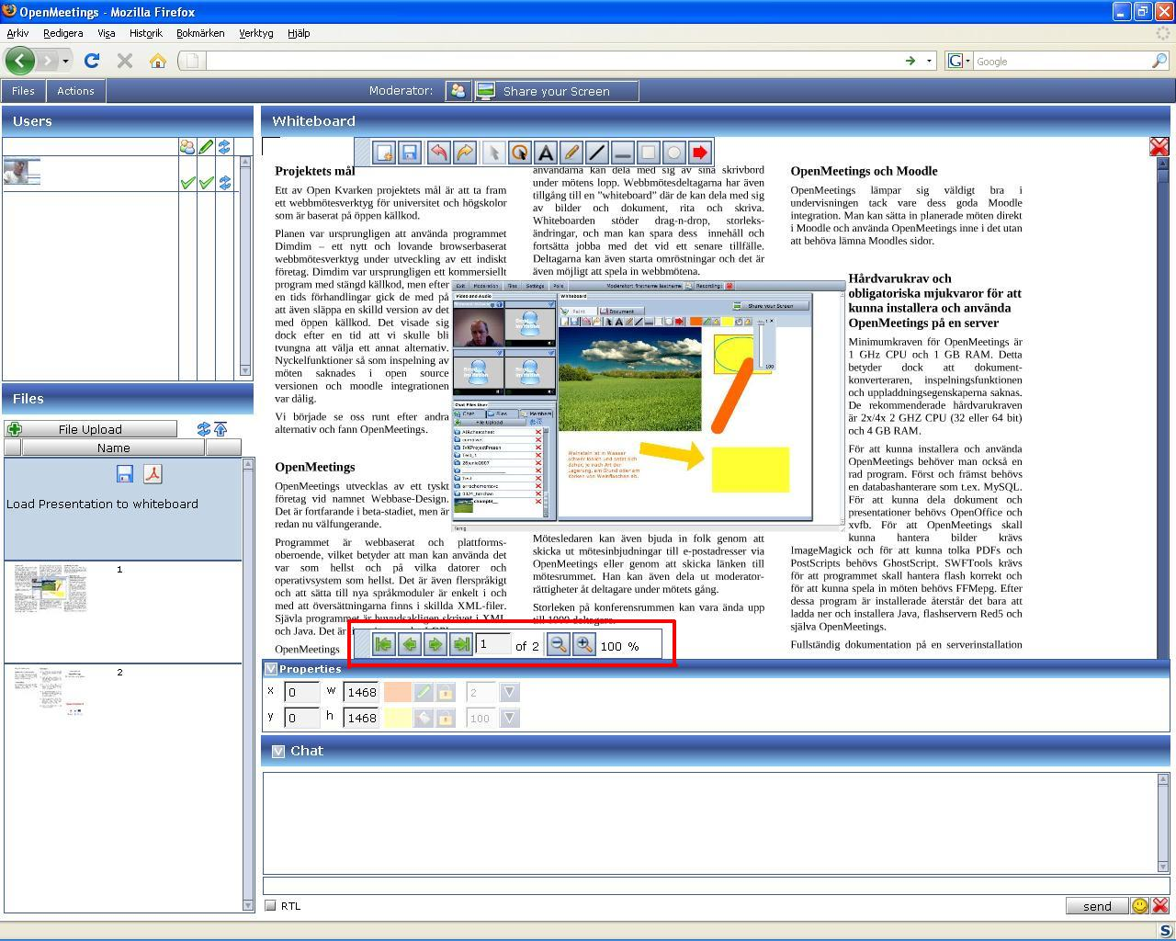
Picture 12 – Here you can see an OpenOffice.org impress presentation, marked with red you can see that it is currently displaying page 1 of 2. The controls are very easy to navigate with.
Currently these file types are viewable on the whiteboard:
.tga, .xcf, .wpg, .txt, .ico, .ttf, .pcd, .pcds, .ps, .psd, .tiff, .bmp, .svg, .dpx, .exr, .jpg, .jpeg, .gif, .png, .ppt, .odp, .odt, .sxw, .wpd, .doc, .rtf, .txt, .ods, .sxc, .xls, .sxi, .pdf
All documents will be converted to a .pdf file and a bunch of .png's which can be used in the conference (drag n drop to the whiteboard) The original file and the .pdf file can be downloaded.

4.2 Upload a file to the whiteboard
If you want to upload a file to the whiteboard you click File Upload, and a new window will appear that says - Choose a file, here you:
- Click Select File
- Locate the file on your hard drive that you want to upload to the whiteboard
- Once you have located the picture you want to use click Open
- Then click Start Upload
- It might take a while but once the file is uploaded but you will see a new entry in the Files (Seen in picture 13 below highlighted with red)
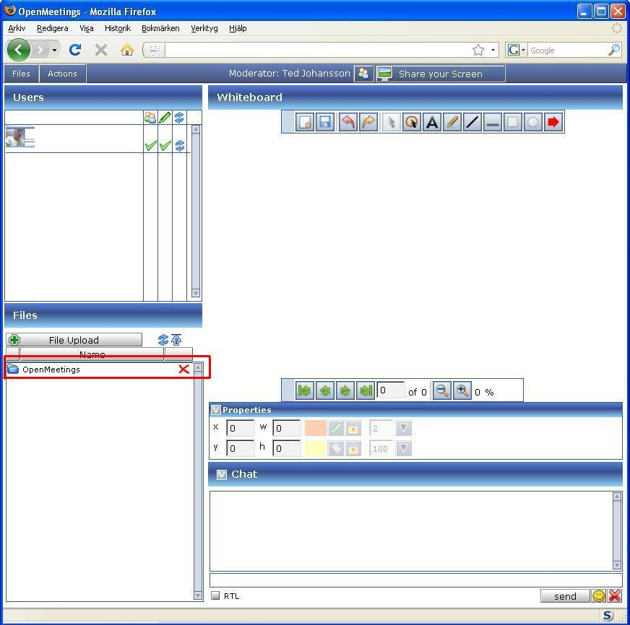
Picture 13 – A view of a conference room where a file has been uploaded, the file has been marked with Red.
Now we want the file we uploaded to be shown in the whiteboard (Note: you have to be a moderator):
- Clicking on the new item (marked with red in picture 13)
- Clicking anywhere within the field that says “Load Presentation to whiteboard”
- Now the file you have chosen will be uploaded onto the whiteboard.

4.3 Saving the whiteboard as an image / Files menu

You can also save the current whiteboard to .png, .jpg, .pdf, .svg, .tif format as seen in picture 14 below
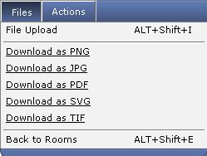
Picture 14 – here you can see the Files menu located in the upper left corner of a conference / auditorium room.
Back to rooms - This takes you back to where you can browse all the rooms.

5. Configuring microphone and webcam

If you need to change the volume on your microphone or need to change webcam you can easily do this by following these simple directions:
- Right clicking somewhere in a room
- Click Settings
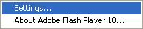
- Click on the microphone icon
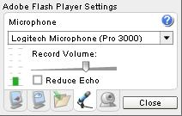
- Drag the volume slider up or down to increase or decrease the volume from your microphone
- Click on the webcam icon
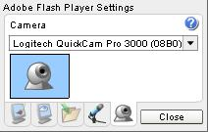
- Here you can choose what webcam you want to use, if you have several that is.

6. Actions menu

The actions menu is found in all rooms in the upper left corner and looks like this:

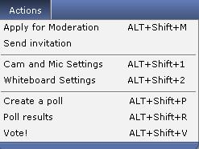
Picture 15 – This is the Actions menu tab, here you can find various options.

Apply for Moderation means you can apply for moderation in the channel, this will give the moderator the question to give you the moderator status, instead of the current moderator.

Send invitation will bring up this window as seen in picture 16 below
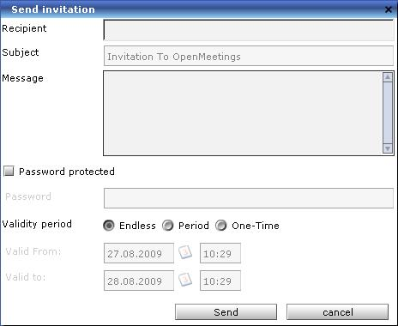
Picture 16 – When sending invitation by mail this window pops up for you to fill.

Recipient – Here you fill in the person’s e-mail address.
Subject – Subject of the mail.
Message – The message you want the recipient to receive.
Password protected – The person you have invited will be asked to verify the password before
being able to log into OpenMeetings.
Validity period – Here you can choose from 3 different types

- Endless The invitation is valid forever, no ending date.
- Period The invitation is valid for a certain time.
- One-Time The invitation is valid only once.

Cam and Mic Settings - Here you can choose what webcam or what microphone you want to use.

Whiteboard settings

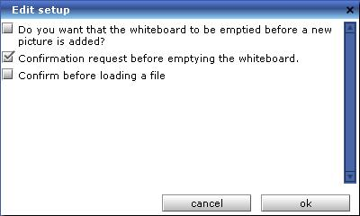
Picture 17 – Here you can see what options you can set for the whiteboard.

Create a poll - If you by any chance want to create a poll, asking a question and want
everyone to answer, you can do so with this option, you can have them answer with a number 1-10 or simply yes or no.

Poll results - Check the results of a previous poll.

Vote! - If a poll is under way you can vote on it by clicking this option.

